CE 444 Assignment 4

Grant Haataja

Safety, Construction, Design, and ADA Fails

­­­­­­­Bintulu, Malaysia

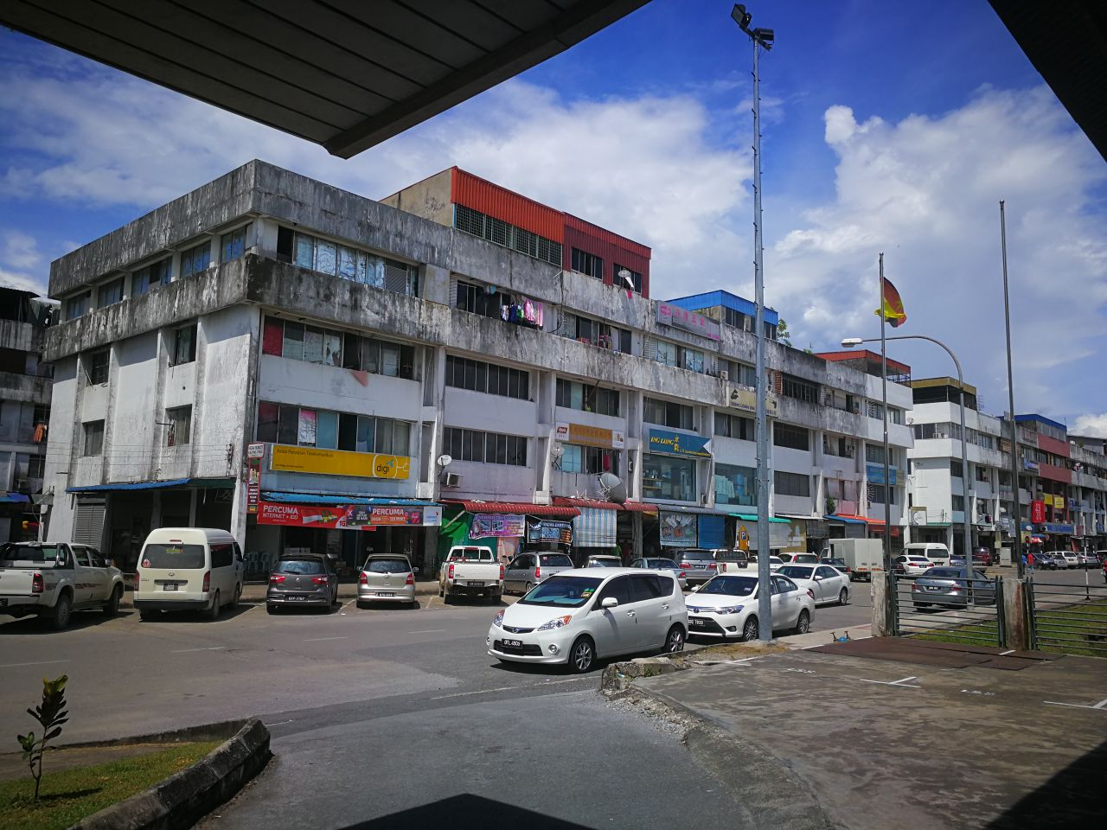

I’m not sure if this one is a design fail or just a maintenance fail, (probably a bit of both). I think they could have used different material to prevent or minimize that awful staining.

Luang Prabang, Laos

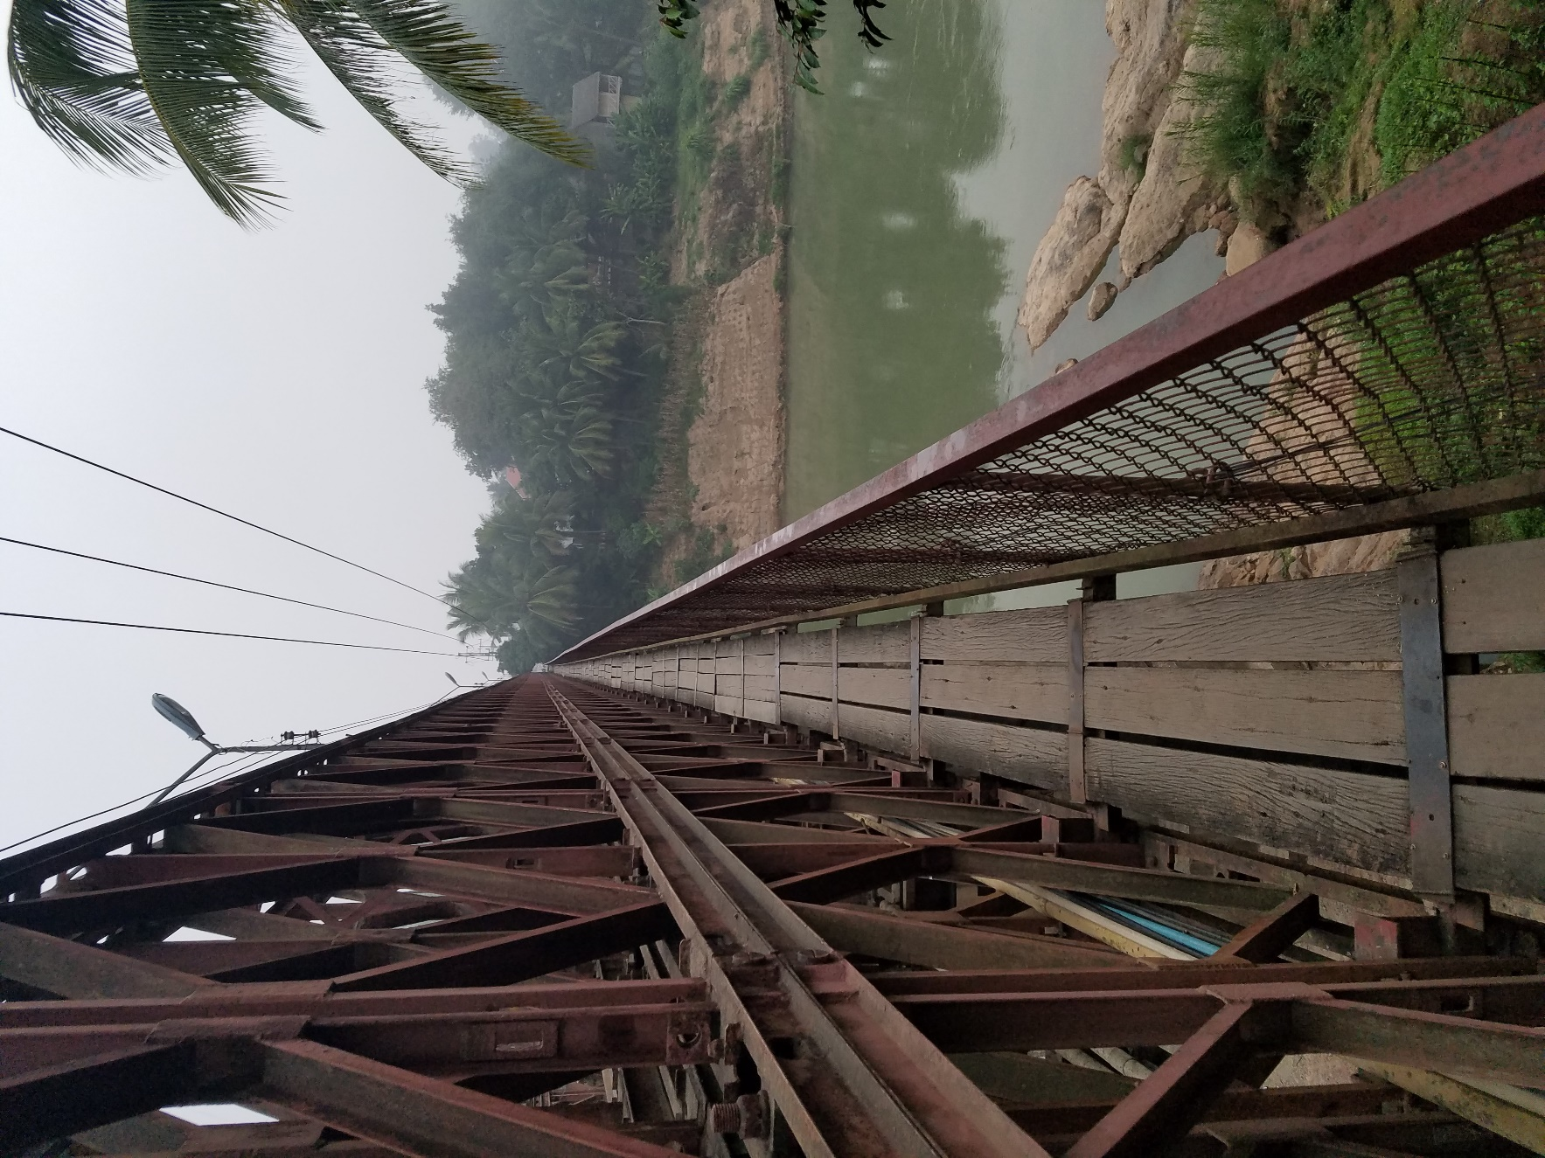

ADA fail for sure, there’s no way you could get a wheelchair across this sketchy bridge.

Near Tioga, North Dakota

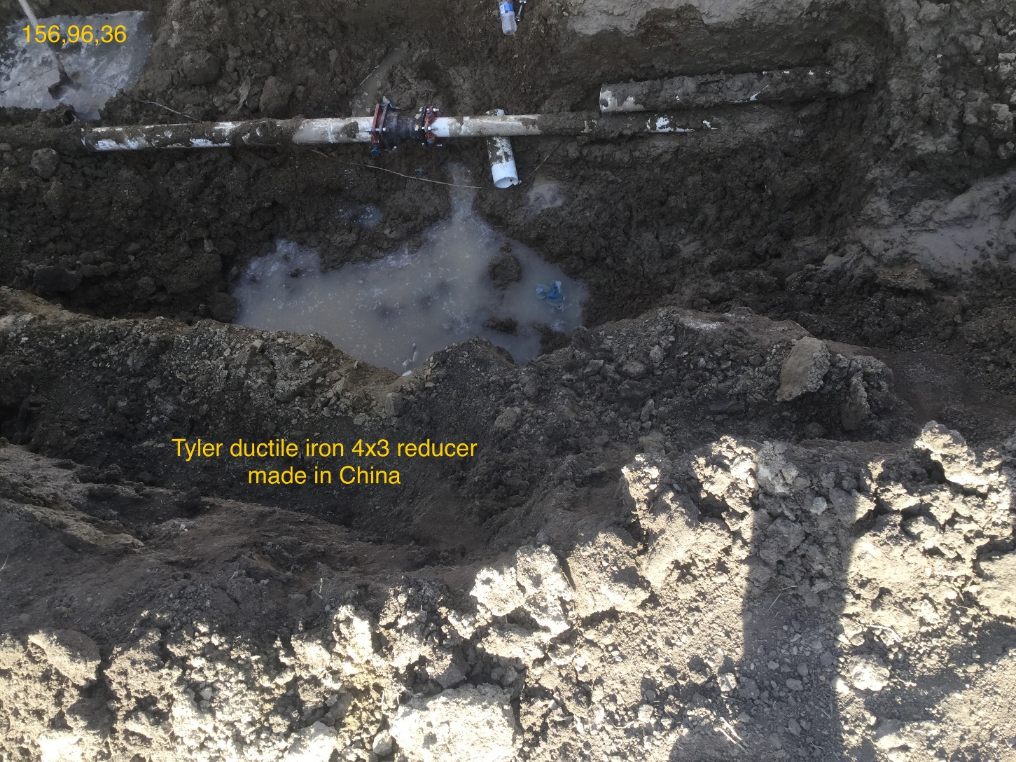

Construction Fail. This was a state-funded job where it was clearly written in the specs that all materials must be made in the USA. When shooting a GPS point on the fitting I saw that it was made in China. They had to shut down for the evening and take it apart and redo it with the proper fitting the next day.

Phuket, Thailand

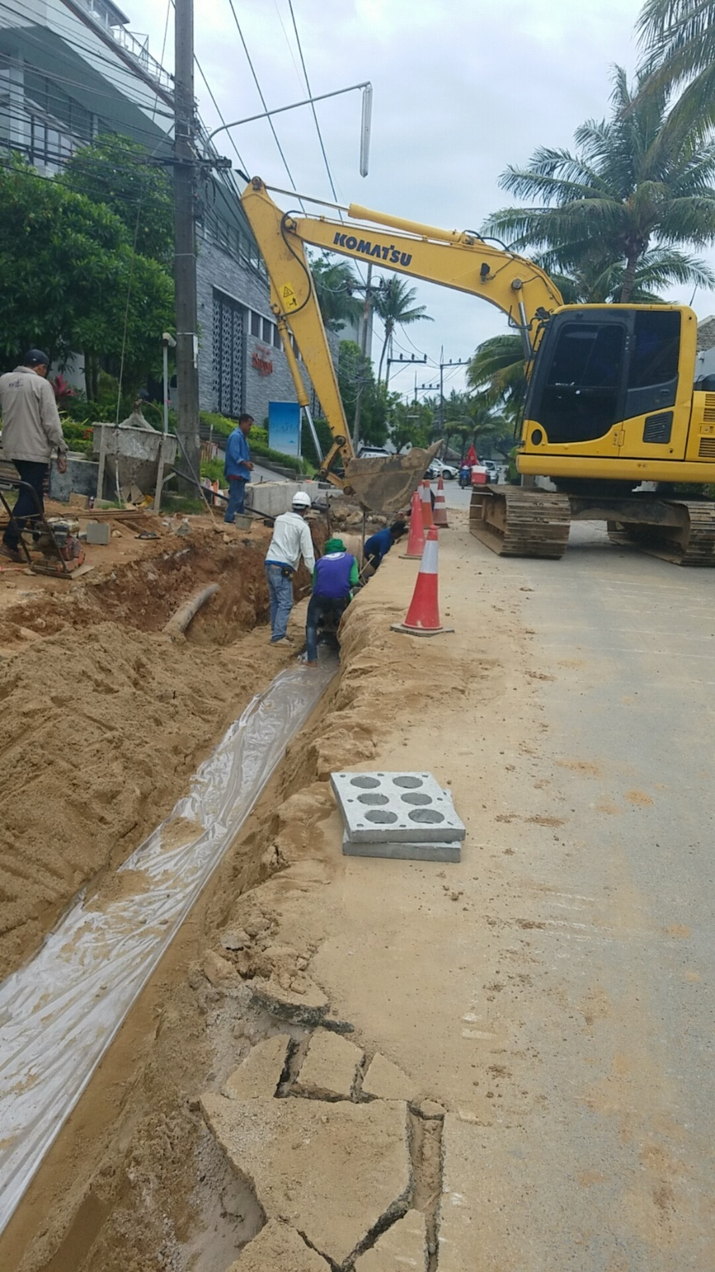

Safety Fail. If you zoom in on the picture you can see that the guy in the purple shirt is not only not wearing a hardhat, but he is also wearing no shoes. Not to mention almost everyone else has no hardhats, and there was no pedestrian control or safety barriers in place on the site.

News Construction and/or Design Fail

<http://abcnews.go.com/US/pedestrian-bridge-florida-international-university-collapses/story?id=53774444>

Pedestrian bridge crossing a highway to and from Florida International University collapsed. I couldn’t find a conclusive report stating what definitely caused the collapse, but it was either a design fail, construction fail, or some combination of both.